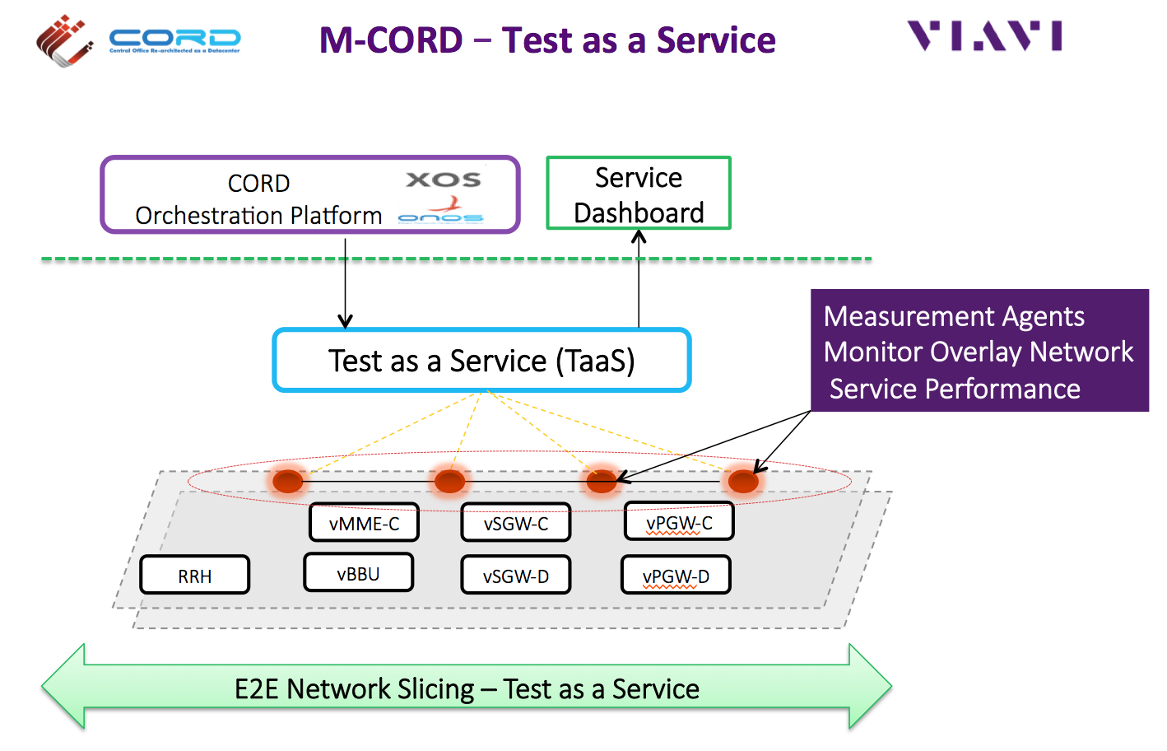

M-CORD Use Case - 'Test as a Service' from Viavi Solutions
October 2016 - Viavi Solutions Inc. is a leading provider of active and passive network service test and monitoring solutions. Viavi joined the M-CORD project to bring real-time service analytics into the M-CORD architecture. In this phase the initial focus has been on orchestration of service testing (Test as a Service, powered by Viavi's EtherASSURE platform). This enables orchestrated active tests to be defined as part of the service model - to dynamically measure overlay/tenant network performance using service activation testing (Y.1564) and IP performance monitoring (TWAMP), between virtual measurement agents dynamically deployed in the virtual network slices and also between virtual agents and smart SFP transceivers in the physical network. The solution follows the open standard LMAP (RFC-7594) for the architecture to ensure a high degree of modularity and integration with both Open Source and other 3rd party network service measurement components.

Next steps: in the next M-CORD project phase, the Test as a Service functionality will be augmented with orchestrated virtual assurance (Assurance as a Service, powered by Viavi's xSIGHT service assurance platform) - this enables service quality monitoring to be automatically deployed along with network service slices, to provide real time information for operations and automated closed-loop control/optimization.
For more information - please refer to Viavi Solutions website www.viavisolutions.com

