At Telefónica’s Product Innovation - Customer Centric Networks department we are developing a CORD-based solution for our PON access network, we have made a slight variation on the choice of components of our solution, but the ONOS-CORD fundamental principles and constructs are being fully utilized.
Taking at heart “everything as a Service XaaS” the aim of our CTpd architecture is to migrate Telefónica’s current residential and business monolithic services to programmable IP services, and to host a new generation of edge-computing services that are furnished not only by Telefónica but from any third party that wants to benefit from a CO’s proximity to the Users.
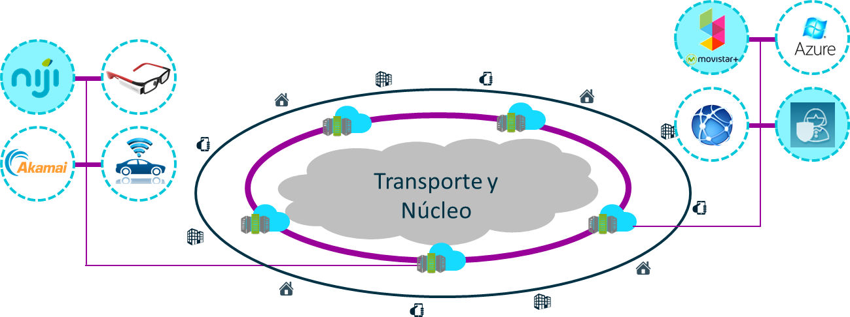
The architectural components chosen for our implementation are depicted in the following diagram:
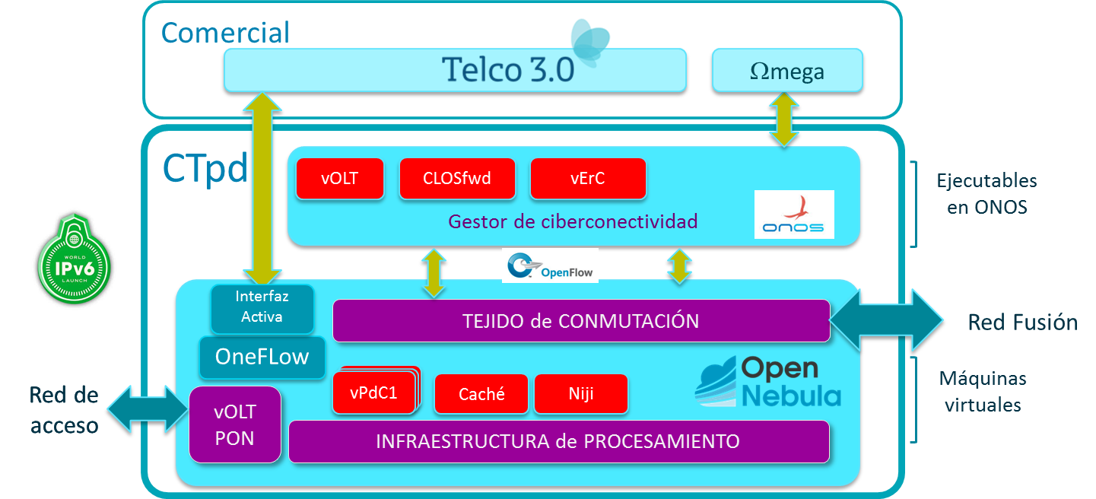

We opted for an all-IPv6 solution in the data plane which allows us to provide advanced networking solutions to our residential customers that otherwise are quite cumbersome to implement.

